System Framework & Hardware integration
Robot Capabilities
• Person detection using ultrasonic sensor
• Greeting response
• Movement control: forward, backward, left, right
• Manual control via Android app (Wi-Fi)
• Automatic mode using proximity sensing

Hardware Integration
Wiring Overview
• ESP32 connects to:
• HC-SR04 (Trig/Echo pins)
• BTS7960 or L293D (motor driver inputs)
• Buzzer (digital output)
• Dual LED display (voltage/current feedback)
• Wi-Fi module (built-in)
• Power Supply:
• Use LM2596S to step down battery voltage to 5V
• AMS1117 for 3.3V devices (e.g., ESP32)
• Motors:
• Connect BTS7960 to high-current motors
• L293D for smaller motors or wheels
• Camera:
Optional Raspberry Pi camera connected to Pi board for streaming

Libraries
- WiFi.h or BluetoothSerial.h for connectivity
- Servo.h or motor control libraries
- NewPing.h for ultrasonic sensor

DFD (main controller)
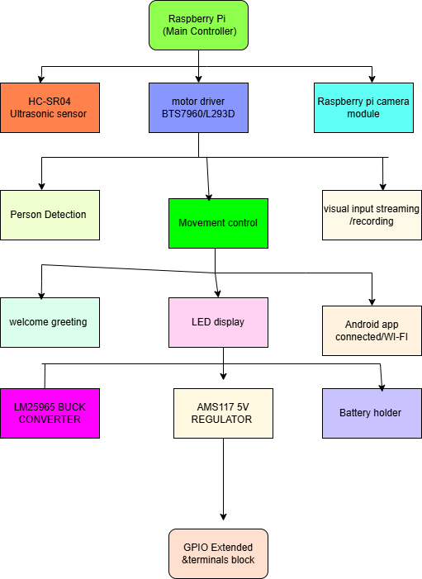

System modes
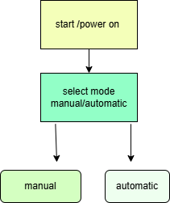

Manual Mode via app
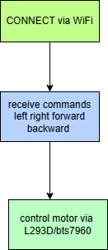

Automatic Mode (ULTRASONIC DETECTION)

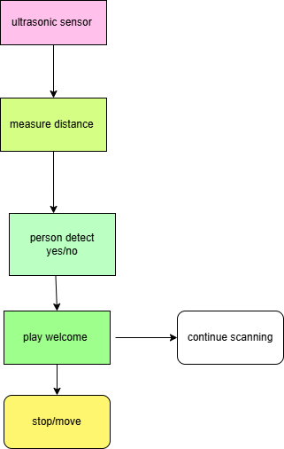

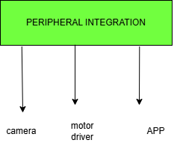
Android App Integration
We have two Communication Options
- Wi-Fi: ESP32 connect to local network
Send HTTP POST Request (from app)
- URL: http: ip address of microcontroller //:5000/move
- Method: POST
- Form Data: dir=forward, backward, left, right)

To connect a React Native app to our Raspberry Pi robot over Wi-Fi, we use HTTP requests from the app to communicate with a Flask server running on the Raspberry Pi.
Architecture Overview
[React Native App] ⇄ [Wi-Fi Network] ⇄ [Raspberry Pi Flask Server] ⇄ [Robot Motors/Sensors]
Raspberry Pi Setup
- Install Flask:
THIS SETUP FOR MICROCONTROLLER
pip3 install flask
- Create Flask Server (robot_server.py)
- Run the server
sudo python3 robot_server.py
- Find your Pi’s IP address:
hostname -I
Use this IP in your React Native app.
React Native App Setup
THIS SETUP FOR APP TO CONNECT ROBOT
- Install Axios for HTTP requests:
npm install axios
- Send Command to Raspberry Pi: here we have have to write code for sending http request by using pi ip address in (js)

